TECHNICAL DOCUMENTATION
How the SOP Chatbot Works — Data Flow, Models & Timing

Overview
This document explains, step by step, exactly what happens inside the chatbot — from the moment an SOP file is uploaded, to the moment an employee's question turns into an answer.
In one sentence
The SOP is chopped into small pieces, each piece is turned into a searchable “fingerprint,” and when someone asks a question, the system finds the closest-matching pieces and hands only those to a local AI model to write the final answer.
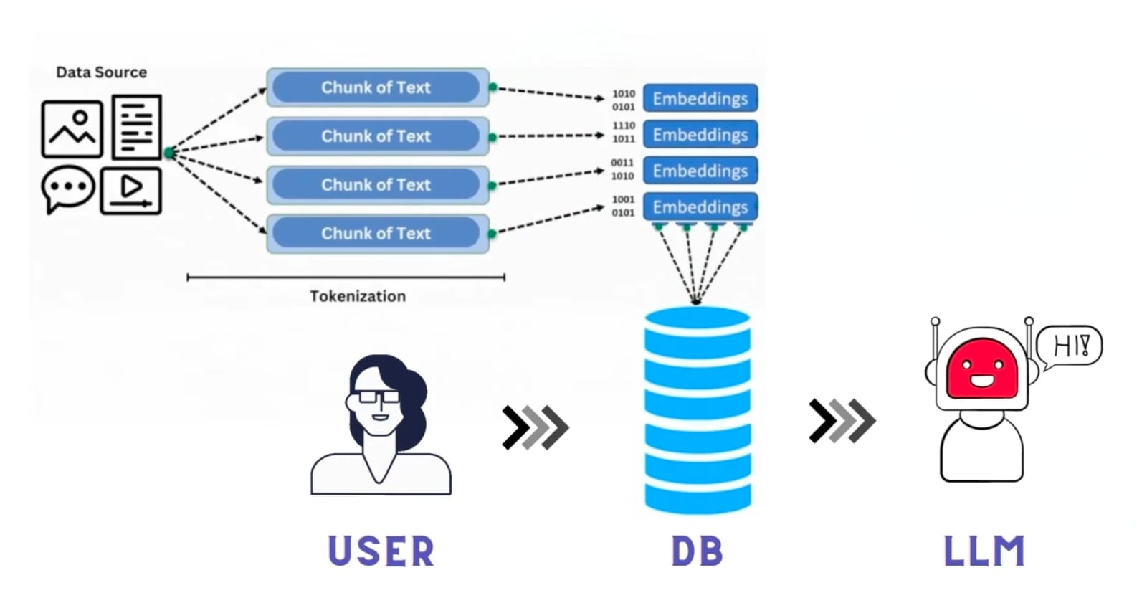
Figure 1: Overall flow — data gets chunked and turned into embeddings stored in a database, then the user's question goes through that same database before reaching the LLM.

1. Data Upload & Processing (Ingestion Pipeline)
This is the one-time (or whenever a document changes) process of adding an SOP into the system.
- Upload: You upload your SOP document (such as a PDF containing both text and images) through the UI.
- Separation: The backend first reads and separates the normal text from the images inside the document.
Chunking (breaking it down):
- Text: The normal text is broken down into smaller paragraphs (chunks) based on headings and semantic meaning.
- Images: The extracted images are sent to the qwen2.5vl:7b model. The model looks at the image and describes what is written or shown in it (captioning). This caption is then converted into a new “text chunk.”
- Embedding (converting to vectors): All the text chunks (both the regular text and the image captions) are passed through the nomic-embed-text model, which converts them into number arrays known as vectors.
- Saving to Database: All these vectors, along with their original text, are saved into a vector database named ChromaDB (stored locally on the computer in a folder named chroma_db/).

How Long This Takes
Scenario | Approximate Time
A typical text-only SOP | 3–8 seconds
Each image inside the SOP (added on top) | +5–15 seconds per image

2. Asking Questions & Getting Answers (Query Pipeline)
This happens live, every time an employee asks a question.
- User Question: You type a question in the chatbot — for example: “What is the leave policy in the SOP?”
- Query Embedding: Your question is also sent to the nomic-embed-text model, where it gets converted into vectors.
- Search in ChromaDB: The system searches ChromaDB to find which SOP chunk vectors closely match the vector of your question (this search uses a combination of vector similarity and keyword matching).
- Top Matches: The database retrieves the top 3 best-matching chunks (which could be normal text or an image caption).
- LLM + SOP Answer: Finally, the system takes your question and those top 3 SOP chunks, and sends them to the main LLM (qwen2.5vl:7b). The LLM reads only those specific SOP chunks, generates an accurate answer, and displays the result to you.

How Long This Takes
Stage | Approximate Time
Retrieval (search + fusion + rerank) | 0.3–0.8 seconds
AI model generating the answer — on GPU | 2–6 seconds
AI model generating the answer — on CPU only | 10–40 seconds
Fallback path (confidence too low, AI skipped) | 0.3–0.5 seconds

3. Why These Specific Models

qwen2.5vl:7b (the answering model)
- Vision-capable — it can read both text and images with one single model, which is why it also handles the image captioning in Part 1.
- 7B size — large enough to write good-quality, natural answers, while still small enough to run comfortably on a local GPU.
- Fully offline — runs entirely on local hardware via Ollama, no cloud API, no internet dependency at runtime.
Why not a bigger, “smarter” model?
A larger model (13B, 30B, 70B+) is more capable at independent reasoning — solving novel problems, drawing its own conclusions, handling open-ended tasks it wasn't directly told the answer to. But that's not this model's job here. By the time qwen2.5vl:7b receives a request, the actual answer has already been found and handed to it (Part 2 above) — its only task is to read the retrieved SOP chunk(s) and restructure that into a clear, natural sentence. That's a structuring/rephrasing task, not a reasoning task, so a bigger model wouldn't produce a more correct answer — it would just cost more GPU memory and run slower for no real gain. The intelligence bottleneck in this system is retrieval accuracy, not the language model's raw capability.

nomic-embed-text (the search/embedding model)
- Runs locally, alongside the other models, no separate service needed.
- Produces 768-dimensional embeddings — a size that balances search accuracy against speed and storage.
- Purpose-built for retrieval quality, which is exactly what the ingestion and search steps above depend on.

4. Databases Used
Database | What It Stores
ChromaDB | The SOP chunks and their embeddings (vectors) — this is what powers the meaning-based search.
SQLite (default) or MySQL | Regular application data: which SOPs exist, chat history, and uploaded file records — the normal, structured data any app needs.

These two databases work side by side, each doing the job it's actually good at — ChromaDB for meaning-based search, SQLite/MySQL for everything else.

5. Why an Offline LLM — Advantages & Security
- No data leaves the building — SOP content, employee questions, and chat history all stay on local/company hardware. Nothing is ever sent to an external AI company's servers.
- No per-query cost — once the hardware is set up, there's no ongoing API bill per question asked, unlike cloud AI services that charge per request.
- Works without internet — the chatbot keeps functioning even if the company's internet connection goes down, since everything runs locally.
- Full control over the model — the exact model version stays fixed until deliberately updated; it won't silently change behavior the way a cloud API might after a provider-side update.
- Reduced compliance risk — for sensitive internal processes (approvals, policy exceptions, security procedures), keeping the data entirely in-house avoids the legal/compliance questions that come with sending internal documents to a third-party cloud service.
- Predictable, auditable behavior — combined with the confidence-threshold fallback, the system has a clear, inspectable rule for when it answers versus when it says “I don't know” — nothing is hidden inside a black-box external API.

6. Hallucination Prevention (Still Working On It) — How We Stop the AI From Making Things Up
This is the single biggest risk with any AI chatbot: the model confidently saying something that isn't true. Below are the seven mechanisms already built into the code (rag-service/main.py) that work together to prevent this.
- Confidence threshold gate (0.45) — if the best-matching chunk's confidence score is below 0.45, the LLM is never called at all. The system returns a direct fallback message instead. main.py:482
- Strict EXTRACTOR system prompt — the model is explicitly instructed to answer only from the given SOP context, never use outside knowledge, quote values verbatim, always give a source line, and say the fallback message if the answer isn't present. main.py:38
- Low temperature (0.2) + top_p (0.9) — these settings remove the model's freedom to “guess” or get creative; it stays in a strict fact-extraction mode instead. main.py:517
- Max 512 token cap — the answer length is capped, so the model can't ramble on into unrelated territory the longer it talks. main.py:519
- Context-first prompting — the model only ever sees the top 3 retrieved chunks plus the question, never the full SOP library. That handed-over context is the entire source of truth for the answer.
- Hybrid retrieval (vector + BM25 + RRF fusion + cross-encoder rerank) — by finding the genuinely correct chunks in the first place, the model is never put in a position where it needs to invent something to fill a gap.
- Query expansion — expanding abbreviations (“PTO” → “paid time off leave”) before searching reduces search misses, which means more relevant chunks reach the model to begin with.
Why seven layers instead of one
No single safeguard is perfect on its own — a confidence threshold can still let through a borderline-relevant chunk, and a system prompt alone can still be occasionally ignored by a model. Stacking multiple independent layers means a failure in one is usually caught by another. This is an ongoing area of work — these seven are what's implemented today, not a finished, closed list.

7. Hardware Specifications Needed
Since this runs on real infrastructure (not a demo laptop), hardware should be sized to expected usage — how many employees may use the chatbot at the same time.
Tier | GPU VRAM | Example Cards | Suitable For
Minimum | 6 GB | RTX 3060 (6GB), RTX 4050 | Both models running, fits tightly — fine for a pilot or a single concurrent user.
Recommended | 8–12 GB | RTX 3060 (12GB), RTX 4060 Ti, RTX A2000 | Comfortable headroom, a handful of concurrent users.
Production | 16 GB+ | RTX 4080, RTX A4000, L4, A10 | Multiple concurrent employees, room to upgrade models later.

- System RAM: 16 GB minimum, 32 GB comfortable — mainly for the OS, the databases, and the retrieval pipeline, not the LLM itself (that lives in VRAM).
- Disk: 20–30 GB free for model weights, ChromaDB storage, and SOP content.
- OS: Linux (Ubuntu) is the standard choice for production; Windows Server also works via Ollama.
- A GPU is strongly recommended, not optional — recall from Part 2 that CPU-only answer generation takes 10–40 seconds versus 2–6 seconds on a GPU.

8. End-to-End Summary
Putting it all together, here is the complete journey from a raw SOP file to an employee getting an answer:
- SOP file uploaded → text and images separated → text split into chunks, images captioned by qwen2.5vl:7b → all chunks embedded (768-dim) → stored in ChromaDB.
- Employee asks a question → question embedded → ChromaDB searched (vector + keyword) → top 3 matching chunks retrieved.
- Question + top 3 chunks sent to qwen2.5vl:7b, which answers using only that content.
Bottom Line
End-to-end, a typical answered question takes roughly 2–7 seconds on a GPU (well under 1 second of that is search — the rest is the AI writing the reply), and a typical new SOP takes a few seconds to a couple of minutes to fully process, depending on how many images it contains.

